Short-term effects of heatwaves on intertidal seagrass: from experimental spectroradiometry to satellite detection
Simon Oiry
Bede Ffinian Rowe Davies¹
Philippe Rosa¹
Augustin Debly¹
Maria Laura Zoffoli
Anne-Laure Barillé
Nicolas Harin³
Pierre Gernez¹
Laurent Barillé¹
2024-11-14
Abstract
Seagrasses are critical to coastal ecosystems, providing habitat, stabilizing sediments, and aiding carbon sequestration. Climate change has increased the frequency and intensity of heatwaves, potentially threatening seagrass health. This study investigates the impact of marine and atmospheric heatwaves on the reflectance of the intertidal seagrass Zostera noltei. We performed laboratory experiments, exposing seagrass samples to controlled heatwave conditions while measuring hyperspectral reflectance to assess impact over time. We found that heatwaves induced significant declines in seagrass reflectance, particularly in the green and near-infrared regions. This corresponded to green leaves turning brown. Furthermore, key vegetation indices, such as the Normalized Difference Vegetation Index (NDVI) and Green Leaf Index (GLI), displayed marked reductions under heatwave stress, with NDVI values decreasing by up to 34% and GLI by 57%. A novel Seagrass Darkening Index (SDI) was developed to identify leaves green colour fading to brown, showing a higher ability to quantify the effect of heatwave exposure seagrass coloration. This research suggests that changes in spectral reflectance can effectively be used to detect the early impacts of heatwaves on seagrasses, providing a valuable tool for remote sensing-based habitat assessment. Multispectral satellite observations confirmed these findings, showing widespread seagrass leaves turning brown during atmospheric and marine heatwave events in South Brittany, France. Darkened seagrasses were observed in areas within the intertidal zone that were exposed to the atmospheric heatwave for more than 13.5 hours a day. This work highlights the need for continuous monitoring of seagrass meadows under the current and future climate regimes, underscoring the potential of remote sensing to capture rapid environmental changes in intertidal zones.

1. Introduction
Intertidal seagrasses play a crucial role in coastal ecosystems by providing habitats and feeding grounds for various marine species, supporting rich marine biodiversity, and contributing significantly to primary production and carbon sequestration (Sousa et al., 2019; Unsworth et al., 2022). These seagrasses are essential for several ecological functions, such as sediment stabilization or reducing the risk of eutrophication by consuming nutrients (Ref.). This justifies their use as indicators of environmental changes due to their sensitivity to water quality variations (Zoffoli et al., 2021). The interactions between seagrass meadows and their associated herbivores further enhance the delivery of ecosystem services, including coastal protection and fisheries support (Gardner and Finlayson, 2018; Jankowska et al., 2019; Zoffoli et al., 2023). Understanding and preserving these ecosystems is vital for maintaining the biodiversity and productivity of coastal regions (Ramesh and Mohanraju, 2020; Scott et al., 2018).

Despite their crucial role in marine ecosystems, intertidal seagrasses face numerous threats that compromise their health and functionality. Coastal development and human activities are primary threats, reducing the available habitat for seagrasses and increasing water turbidity, limiting light penetration and photosynthesis (Waycott et al., 2009). Seagrasses are also threatened by agricultural and urban runoff nutrient enrichment, leading to eutrophication. This condition promotes the rapid growth of algal causing blooms that compete with seagrasses for light and nutrients, further stressing these important plants (Thomsen et al., 2023) (Oiry et al. 2024). Pollution from industrial and agricultural sources introduces harmful chemicals and heavy metals into coastal waters, posing toxic risks to seagrass health (Bastos et al., 2023; Zahoor and Mushtaq, 2023). These pollutants can affect the physiological processes of seagrasses, reducing their growth and survival rates (Sevgi and Leblebici, 2022). Among these anthropogenic stressors,
heatwaves, exacerbated by climate change, pose a growing threat to seagrasses (Deguette et al., 2022; Sawall et al., 2021). However, their impact on seagrass spectral reflectance has not yet been investigated.

Marine Heatwaves (MHW) are defined by Hobday et al. (2016) as prolonged discrete anomalously warm water events, while Atmospheric Heatwaves (AHW), are defined by Perkins and Alexander (2013) as periods of at least three consecutive days with temperatures exceeding the 90th percentile of a times series covering at least 30 years. Intertidal seagrasses are exposed to both MHW and AHW at the interface between the land and oceans. Heatwaves profoundly impact the physiology of seagrasses, with their effects varying based on species and geographic location. The Atlantic species Zostera marina exhibits high susceptibility to elevated sea surface temperatures during winter and spring, leading to advanced flowering, high mortality rates, and reduced biomass (Sawall et al., 2021). Similarly, Cymodocea nodosa shows increased photosynthetic activity during heatwaves but suffers negative effects on photosynthetic performance and leaf biomass during recovery (Deguette et al., 2022). Additionally, different populations of Zostera marina along the European thermal gradient exhibit varied photophysiological responses during the recovery phase of heatwaves, indicating differential adaptation capabilities among populations (Winters et al., 2011). These events intensify other stressors, such as overgrazing and seed burial, compromising recruitment (Guerrero-Meseguer et al., 2020). Structural impacts on the colour of the leaves are also happening: in September 2021, a meadow was observed in South Brittany (France), where the leaves turned brown a few days after a heatwave (Barillé A-L. & Harin N., comm. pers). We hypothesized that optical methods could detect and quantify these colour changes.

Remote sensing is increasingly being used to monitor intertidal seagrass meadows (Davies et al., 2024a, 2024b). Spectral indices such as the Normalized Difference Vegetation Index (NDVI) and the Green Leaf Index (GLI) are effective for quantifying vegetation health over time (Akbar et al., 2020; Cârlan et al., 2020; Huete, 2012; Kloos et al., 2021). By analyzing specific spectral patterns, remote sensing can track changes in seagrass meadows with high temporal and spatial resolution.
This study aims firstly to experimentally test the hypothesis that heatwaves alter the reflectance of the intertidal seagrass Zostera noltei and therefore the colour of the leaves By linking these changes with satellite remote sensing data, the study seeks to provide insights into how heatwaves affect seagrass meadows and to assess the potential of remote sensing in monitoring these impacts

2. Material & Methods

2.1 Laboratory Experiment

2.1.1 Sampling and acclimation of seagrasses
Seagrass samples were taken from a Zostera noltei (dwarf eelgrass) meadow in Bourgneuf bay, France (46°57’32.0”N, 2°10’37.0”W) at low tide in June 2024. A metal sampling box was used to sample seagrass from an area of 30 cm by 15 cm and 5 cm deep, maintaining the sediment structure and avoiding damage to the rhizomes and the leaves of the seagrass (Figure 1 A). This sampling box limited variability between replicates. The sampled sediment including seagrass, sediment, meiofauna, and macrofauna, was placed in plastic trays . Keeping the entire biota allowed for the natural interactions between components to be maintained and reduced stress on the seagrass. Seawater was added to each tray to avoid hydric stress caused by insufficient moisture during transportation. Simultaneously, seawater was sampled from a nearby site and transported to the lab, where it was filtered using a 0.22 µm nitrocellulose filter to remove all suspended particulate matter. This seawater was used in the acclimation tank and the intertidal chambers. The seagrasses were acclimated for one week with a water temperature of 17°C, matching the in situ temperature during sampling, and with light of 150 µmol.s⁻¹.m⁻² of PAR photons (Akbar et al., 2020). During high tide, a pump allowed the water to circulate and to re-oxygenate.
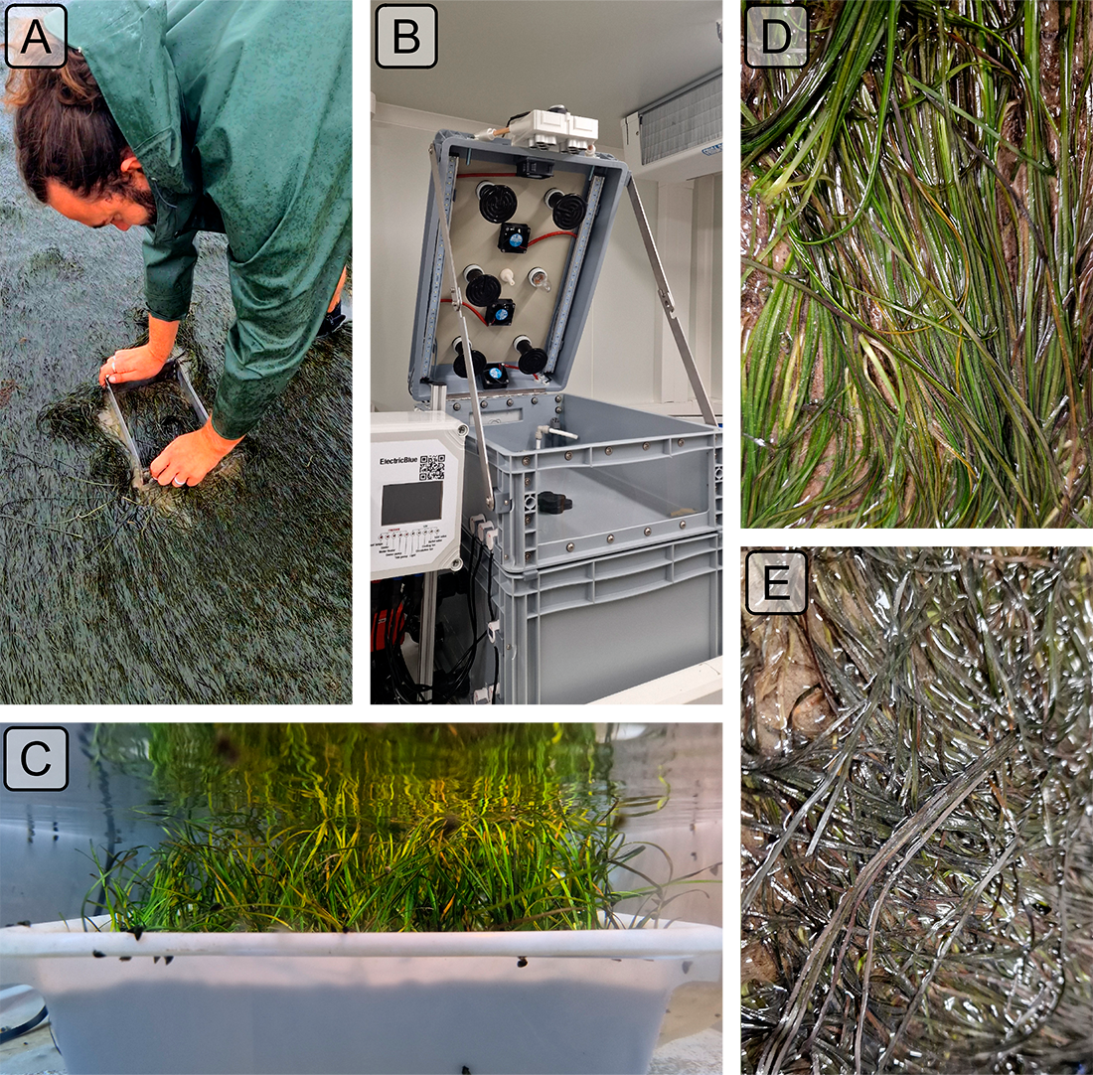
Figure 1: Example of the various steps of the experiment. A: Field sampling of seagrass using a sampling coring device; B: Intertidal chamber used during the experiment; C: Seagrass sample inside a chamber during the experiment at high tide; D: Treatment sample at the start of the experiment; E: Treatment sample two days after the heatwave.

2.1.2 Experimental design
Two experimental intertidal chambers from ElectricBlue® (https://electricblue.eu/intertidal-chamber) were used to simulate tidal cycles and control water temperature during high tide and air temperature during low tide(Figure 1). The chambers were utilized in parallel, with one serving as the control, while the other was used for the experimental treatment.
To closely reproduce field temperatures experienced by seagrasses during the experiment, in situ temperature sensors (T7.3 EnvLoggers from from ElectricBlue®) were installed at the sampling site in Bourgneuf Bay in August 2024. Daily maximum temperatures recorded by these in situ sensors were compared to measurements from the nearest Meteo France weather station (Annexe A1, Section 6.1). The control chamber was kept at temperatures representing typical seasonal conditions, with water temperatures at 18°C and air temperatures from 19°C to 23°C, following natural daily temperature fluctuations (Figure 2). For the experimental treatment, the air temperature was adjusted to mimic an atmospheric heatwave that affected the seagrass meadow in Quiberon, South Brittany, France (47°35’40.0”N, 3°07’30.0”W), from September 2 to September 6, 2021. On the first day of the experiment, air temperatures in the experimental chamber were set to range from 23°C at night to 35°C during the day, increasing by 1°C daily during three days. Water temperature in the experimental chamber was also adjusted to mimic heatwave conditions, starting at the seasonal baseline (18°C) and rising incrementally by 0.5°C daily to simulate the increasing temperatures during the heatwave. This aimed to reproduce the thermal stress experienced by the seagrass meadow during this heatwave event (Figure 2). This experiment was repeated three times to obtain replicates (Run) for the GLM statistical analysis.

2.1.3 Optical measurements

2.1.3.1 Hyperspectral measurements
Throughout the experiment, hyperspectral signatures of both the control and treatment seagrasses were taken using an ASD HandHeld 2 equipped with a fiber optic extension, allowing measurements to be taken directly inside the chamber without opening it, where automatic spectra acquisition was carried out (Malvern Panalytical, 2023). An average of five reflectance spectra ($R\left(λ\right)$), each with an integration time of 544 ms, was taken every minute during daytime. Every 10 minutes, the fiber optic was switched from one intertidal chamber to the other, to measure reflectance in both treatment and control. Light conditions were controlled inside of the chambers so reflectance calibration of the instrument was performed each morning at the very first moment of low tide using a Spectralon white reference with 99% Lambertian reflectivity.

2.1.3.2 Spectrum post-processing
A Savitzky-Golay smoothing function with a 5 nm moving window was applied to each spectrum usingRλ the “hsdar” package in R (Lehnert et al., 2017). The second derivative at 665 nm (δδ₆₆₅), showing the highest variability between the control and the treatment, was tested as an indicator of the spectral changes following heatwaves.
Two additional well-established radiometric indices were also tested.
The Normalized Difference Vegetation Index (NDVI, Rouse et al. (1974)), a proxy of the concentration of chlorophyll-a (Equation 1)
$$NDVI=\frac{R\left(840\right)-R\left(668\right)}{R\left(840\right)+R\left(668\right)} \left(1\right)$$
where $R\left(840\right)$ and $R\left(668\right)$ are the reflectance at 840 nm and 668 nm respectively. The
Green Leaf Index (GLI, Louhaichi et al. (2001)), a measurement of the greenness of seagrass leaves (Equation 2)
$$GLI=\frac{\left[R\left(550\right)-R\left(668\right)\right]+\left[R\left(550\right)-R\left(450\right)\right]}{\left(2×R\left(550\right)\right)+R\left(668\right)+R\left(450\right)} \left(2\right)$$
where $R\left(550\right)$ and $R\left(450\right)$ are the reflectance in green at 550 nm and in the blue at 450 nm, respectively.
Based on the observed spectral changes in seagrasses exposed to heatwaves, we developed a new radiometric index to detect colour changes in the visible but also near-infrared slope variations, a significant spectral feature for seagrasses (Davies et al. 2023). The observed green colour of the leaves turning brown was characterized by a reduction in reflectance within the green region and a substantial decrease in the red-edge portion of the electromagnetic spectrum.
The Seagrass Darkening Index (SDI) is introduced here to measure the difference between the interpolated value between 560 and 842 nm and the observed value at 740 nm (Figure 3). This approach calculates the line height using a triplet of bands, where 560 nm and 842 nm serve as the ‘baseline’ and 740 nm represents the central peak. The SDI can be mathematically expressed as:
$$\text{SDI}=I_{SDI}-R\left(740\right) \left(3\right)$$
where :
$$I_{SDI}=R\left(560\right)+τ\left[R\left(842\right)-R\left(560\right)\right]$$
and :
$$τ=\frac{740-560}{842-560}$$
Where $R\left(560\right)$, $R\left(740\right)$, and $R\left(842\right)$ represent reflectance values at 560, 740, and 842 nm, respectively. These wavelengths were selected to align with the spectral resolution of satellites like Sentinel-2, enabling the index to map leaves browning from satellite data. Negative SDI values indicate green, healthy seagrasses, while positive values correspond to brown leaves.

2.2 Observations of a seagrass bed impacted by a heatwave

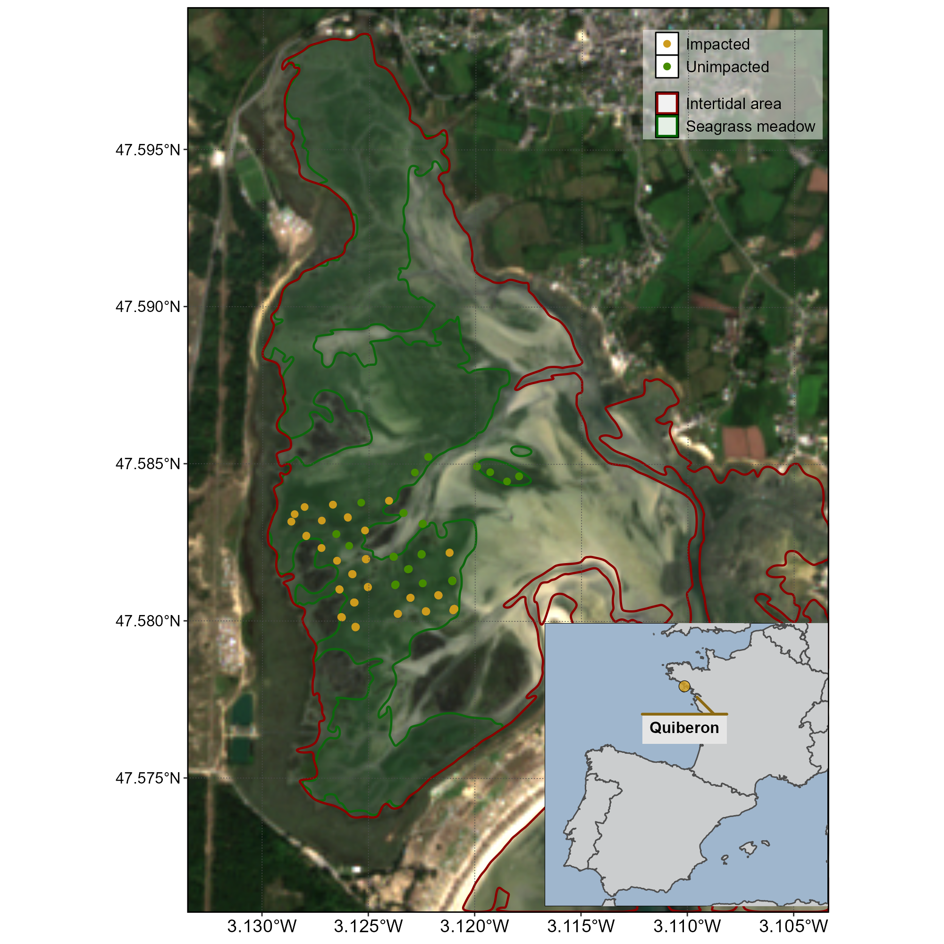
Figure 2: Locations of field observations in a seagrass meadow impacted by a heatwave that occurred on the 10th of September 2021 in Quiberon, South Brittany, France. The red line indicates the intertidal zone (Zone between high tide and low tide that totally emerges at low tide) and the green polygon indicates the extent of the seagrass meadow. Green dots indicate the location of the quadrat picture over unimpacted seagrasses (i.e. showing a green colour on the field), while orange-red dots indicate the location of the quadrat taken over impacted seagrasses (i.e. showing a brown colour on the field).
A field campaign aiming to map a seagrass meadow near Quiberon, South Brittany (France : 46°57’32.0”N, 2°10’37.0”W), occurred on the 10th of September 2021 after a heatwave (Figure 2). Seagrass leaves turned brown were observed over large areas of the meadow alongside normal green seagrass (Figure 3). A total of 96 Quadrat Points (QPs) were collected as georeferenced quadrat images across the meadow. These images allow for visual assessment of vegetation type and coloration. The quadrats were then divided into two categories: green seagrasses (henceforth: QPs unimpacted) and brown seagrasses (henceforth: QPs impacted), based on a visual estimation of the leaf coloration (Figure 4).
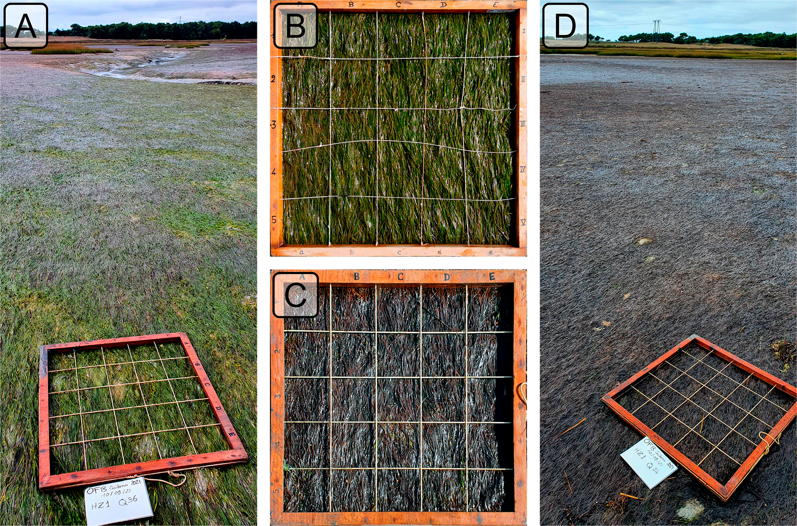
Figure 4: Illustrations of the two colorations of seagrass leaves observed in the field. A: View of a green meadow; B: Quadrat with green leaves; C: Quadrat with brown leaves ; D: View of a meadow with all leaves turned brown. All images were taken on September 10th, 2021, in Quiberon, South Brittany, France, after a heatwave.

2.2.1 Temperature data and identification of the heatwave

Air temperature
Since January 1, 2024, Meteo France weather data has been freely and openly accessible. Hourly air temperature data (°C) was retrieved using a custom script as no API was available at the time of this study. Data from the nearest weather station of our study site (Lorient-Lann Bihoue, 47°45’46”N 3°26’11”W) were downloaded. For this station, more than 395,000 observations since February 1, 1952, were available.

Water temperature
SST data from the Copernicus CMEMS platform were downloaded for the French coast near Quiberon (47°29′03″N, 3°07′09″W), covering 1982-2022 (CMEMS, 2024). Only pixels within an area of 2700 km² around Quiberon, Brittany, France (47°29′03″N, 3°07′09″W) were extracted and analyzed. This area was large enough to minimize missing values caused by cloud cover yet small enough to avoid being influenced by the stability of offshore SST.

Heatwave detection and characterization
Heatwave detection was performed using the HeatwaveR package in R (Schlegel and Smit, 2018). This package utilises the methodology proposed by Hobday et al. (2016) to detect heatwave events. The climatology for the year was computed using the temperature time series from 1952 to 2024. An event was considered a heatwave each time the temperature exceeded the 90th percentile of the climatology for three consecutive days. The severity of each event has been assessed using the methodology proposed by Hobday et al. (2018).

2.2. Satellite observation
Three Sentinel-2 images covering the field campaign site (Figure 2) were downloaded from the Copernicus platform (European Space Agency, 2024a). The first image was taken before the heatwave event on September 1st, 2021, the second image during the event on September 6th, 2021 and the last one, one month after the heatwave on the 8th of October 2021. Images were acquired as Level-2 product, in surface reflectance, and were orthorectified and atmospherically corrected to account for the effects of the atmosphere on reflectance values (European Space Agency, 2024b).
The reflectance value of each QP (Figure 4) was extracted and compared before and after the heatwave event.

SC=172.06×NDVI-22.18 4

2.2.4 Emersion time of the seagrass meadow
To estimate the spatial distribution of the emersion time of the seagrass meadow during low tide, bathymetric and tidal data were used. The hypothesis was that the leaf's discolouration following the heatwave was related to the emersion time and intertidal topography. Bathymetry data for the Quiberon intertidal meadow were sourced from the “Service Hydrographique et Océanographique de la Marine” (SHOM, 2021). It corresponds to the Litto3D® product, which is a three-dimensional land-sea elevation database that accurately depicts the coastal terrain along the French coast. It uses the NGF/IGN69 reference “zero”, which corresponds to the mean sea level recorded at the Marseille tide gauge between 1885 and 1897, commonly known as the “Terrestrial Altimetric Zero”.
Tidal data during the heatwave event were downloaded from the Intergovernmental Oceanographic Commission data portal (IOC, 2024), using measurements from the nearest tide gauge at Le Crouesty. In this dataset, the reference “zero” corresponds to the lowest astronomical tide, also known as the Hydrographic Zero.
Before calculating the emersion time, both datasets were intercalibrated to a common altitude reference. This involved applying a correction factor to the Litto3D data to align it with the Hydrographic zero. SHOM annually publishes a document called “Références Altimétriques Marines” (RAM, Shom, 2022), which provides these correction factors for each seaport along the French coastline. The correction factor for Le Crouesty port data from 2022 was 2.85 m.
Once aligned, the corrected elevation was compared to water height for each pixel and each time step during the heatwave event. The emersion time was then calculated as the daily total time each pixel remained exposed.

2.3 Statistics
General Linear Models (GLMs) were used to assess relative differences over time in response variables (Spectral Indices) with different treatments. For analysis of relative changes in indices calculated from experimental spectra the relative change in index was modelled as function of Days (1-3: Discrete) with Run (1-3: Factor) and Timestep within Run (1-6: Factor) as cross random factors. Satellite derived indices were modelled as function of Date (1-3: Discrete) and Treatment (Impacted vs Unimpacted: Categorical). A General Additive Model (GAM) was used to assess the relationship between relative SDI change with emersion time. SDI was modelled as function of emersion time with a basis spline. All model parameters were estimated with a Bayesian framework using the “brms” and “RStan” packages in R to leverage the stan language (Bürkner, 2021; Carpenter et al., 2017; R Core Team, 2023; Stan Development Team et al., 2020). The response variables were modelled assuming a Gaussian distribution, with weakly informative priors (Student-T(3,0,2.5)). Model parameters were estimated using Markov Chain Monte Carlo (MCMC) sampling, with 4 chains of 5000 iterations and a warm-up of 500.

3. Results

3.1 Laboratory Experiment

3.1.1 Seagrass spectral variations related to a heatwave
In the Control group, reflectance remained relatively stable over time, with only minimal changes in magnitude and spectral features (Figure 5). Overall, the Control group’s reflectance spectra displayed a peak at 560 nm (green region), low values at 665 nm (indicative of strong chlorophyll-a absorption), and a high plateau in the near-infrared (NIR), beyond 705 nm (Figure 5, left).
In contrast, the Treatment group simulating a heatwave showed more pronounced changes in reflectance throughout the experiment (Figure 4, right). At the beginning (Day 1), reflectance values were comparable to those in the Control group, especially in the visible region, with a notable peak around 560 nm and a pronounced trough at 665 nm. However, starting from day 2, reflectance began to decrease across all wavelengths, particularly around 560 nm and in the NIR. At day 3, the NIR reflectance appeared to stabilize at values like those observed during day 2. In the green region, however, reflectance continued to decline slightly until the experiment’s conclusion.
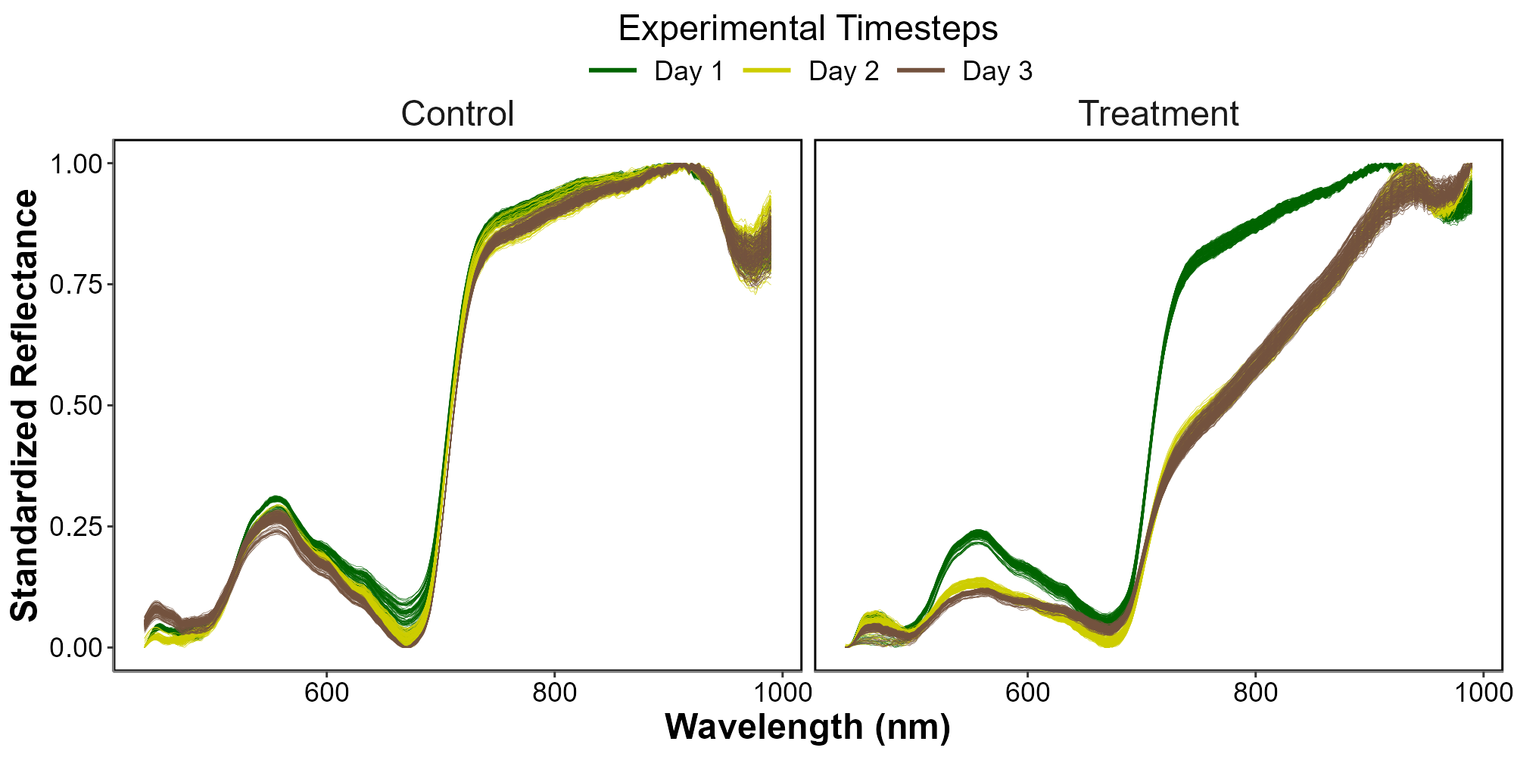
Figure 5: Standardized hyperspectral reflectance of Z. noltei leaves measured during the heatwave experiment for both the Control (Left) and the Treatment (Right). Color denotes the progression along the experiment from the beginning (Day 1: green), middle (Day 2: Yellow) and end (Day 3: Brown). A min-max standardization has been applied to each individual spectrum.

3.1.2 Comparison of spectral metrics to detect heatwave effects on seagrass leaves

R″λ0.95×10-4
Similar patterns were found for the ($R″_{665 \text{nm}}$), NDVI and GLI, where the indices start similar to the control and consistently decline over the 3 days of experiment (Figure 5 B)
At the start of the experiment (day 1) $R″_{665 \text{nm}}$, NDVI and GLI in the Treatment group were on average 13% greater, 3% lower and 2% lower, respectively, than that of the Control. However, by day 2, the Treatment showed a rapid decease of approximately 27%, 17% and 28%, eventually reaching a total decline of 68%, 31% and 54% by day 3.
Unlike the other metrics, at the start of the experiment (day 1), the SDI for the Treatment group was on average 55 % greater than that of the Control. By day 2, the SDI for the Treatment exhibited a rapid decrease of approximately 241 %, eventually reaching a cumulative decline of 420 % by day 3 (Figure 5 E).
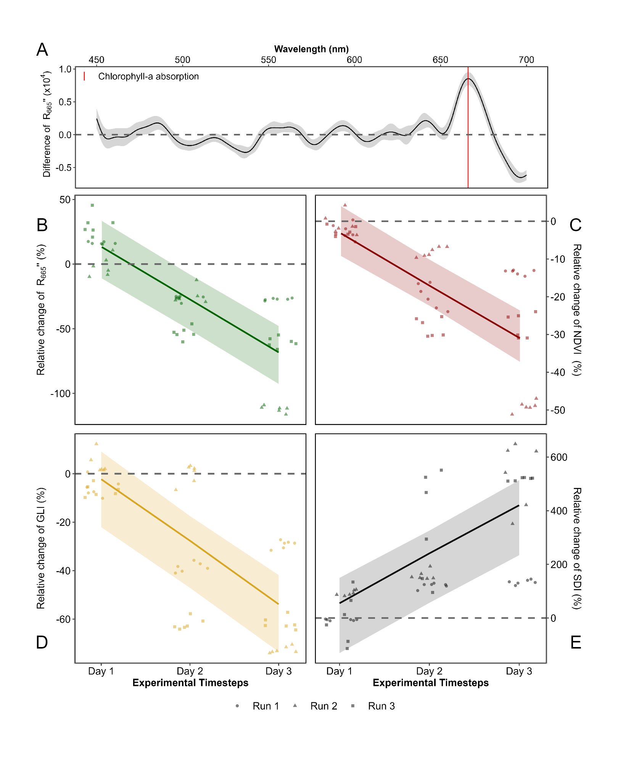
Figure 5: Comparison of spectral metrics for detecting reflectance changes of seagrass leaves after a heatwave. (A) relative difference of the second derivative at 665 nm between between the Control and the Treatment over time (B), relative difference of the NDVI, (C) relative difference of the GLI and (D) relative difference of the SDI. Points indicate raw data, the line represents a generalized linear model, and the shaded area is the model’s standard error. The dashed lines represent no difference between the Control and the Treatment.
The SDI revealed clear distinctions between the Control and Treatment groups (Figure 6). At day 1, the SDI of the Control and Treatment groups are By the end of the experiment, seagrasses in the Treatment group exhibited an average SDI of 0.15, consistent with their visibly darkened appearance. In contrast, the Control group retained a green appearance throughout the experiment, with an average SDI of -0.07.
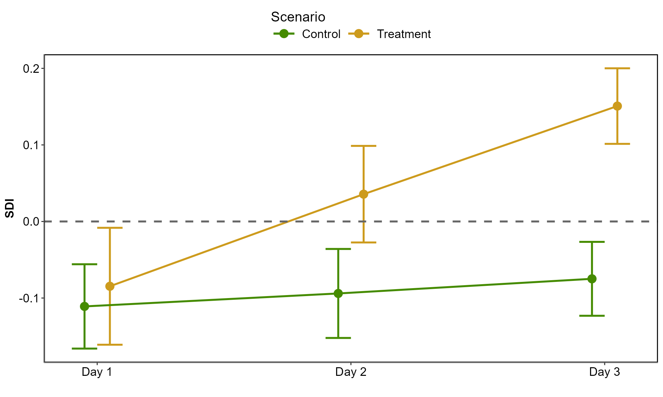
Figure 6: Average and standard deviation of the Seagrass Darkening Index (SDI) across expimental runs, at each day of the experiment. The green line shows the values of the Control group, while the orange line indicates the values of the Treatment group.

3.2 Heatwave of September 2021 in South Brittany

3.2.1 Spectral changes
The Sentinel-2 images analysed in this study are dated from the 1st of September 2021 and the 6th of September 2021 (Figure 7 A and C, respectively). The Atmospheric Heat Wave (AHW) started on the 4th of September and lasted until the 7th of September, while the Marine Heat Wave (MHW) started on the 3rd of September and ended on the 8th September 2021 (Figure 7 B). The AHW has been classified as a strong event, and the MHW was classified as moderate. The Sentinel-2 image of the 6th of September was captured two days after the start of the AHW and seagrass leaves turned brown can already be observed in the true-colour composition (Figure 7 C) compared to the reference from the 1st of September 2021 before the heatwaves (Figure 7 A). Before the event, all QPs appeared green on the images, with similar reflectance typical of green seagrass leaves (Figure 7 A and D left). Their reflectance spectra showed a peak at 560 nm (in the green part of the spectra), low values at 665 nm and a high infrared plateau (> 705 nm). However, on the 6th of September, QPs classified as impacted during the field campaign, showed significant differences in their reflectance spectral shape compared to unimpacted (Figure 7 E). The reflectance spectra of brown seagrass were characterised by the loss of the reflectance peak at 560 nm and a decrease in the infrared plateau, which was replaced by a steadily increasing slope up to 940 nm. The darkening of large areas within the seagrass meadow could also be observed in the true colour composition (Figure 7C).
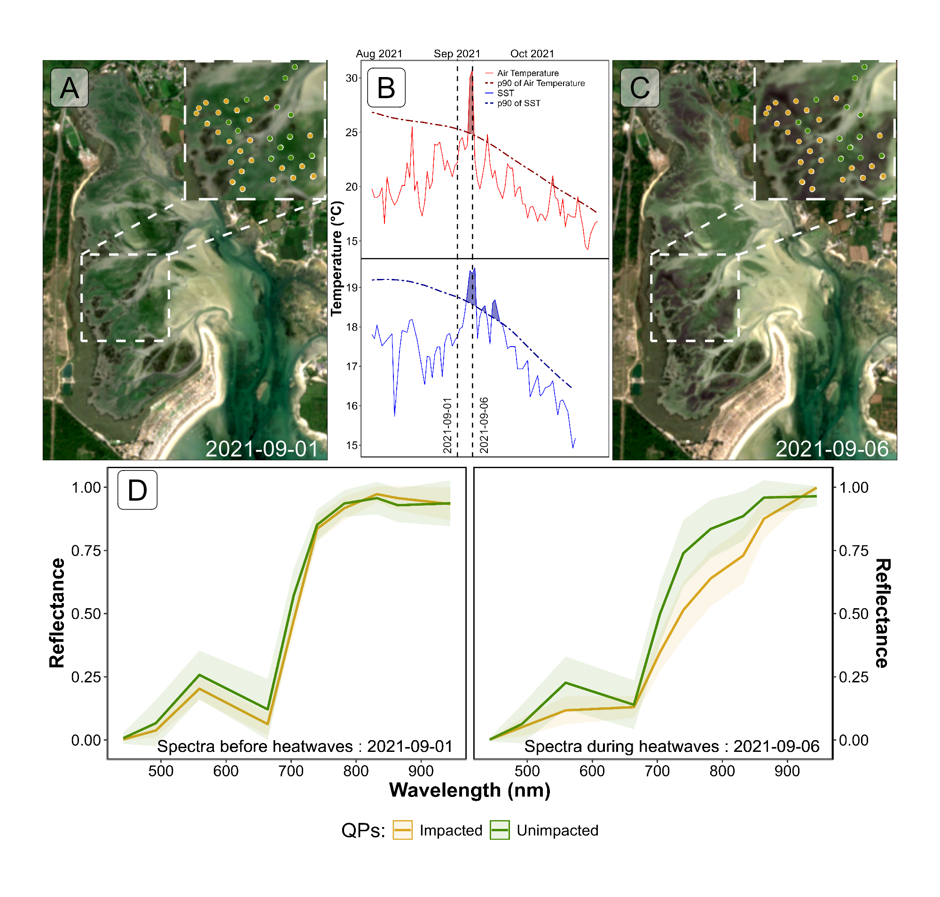
Figure 7: Intertidal seagrass meadow in South Brittany (France) observed before and during a heatwave (HW). A) RGB color composition of the Sentinel-2 image on the 1st of September 2021 before the HW. C) RGB color composition of the Sentinel-2 image on the 6th of September 2021 on the second day of a strong AHW. The circles correspond to Quadrat Points (QPs) collected on September 10, 2021, with unimpacted seagrass in green and impacted seagrass in orange. B) Detection of heatwave events based on both Air Temperature and Sea Surface Temperature (SST). The solid line represents the daily average temperature, while the dashed line indicates the 90th percentile of the climatology. Coloured areas identify heatwaves (marine in blue and atmospherical in red). The two vertical dashed lines represent the acquisition dates of the two Sentinel-2 images used in this analysis (01-09-2021 and 06-09-2021). D) Sentinel-2 reflectance of seagrass leaves before the HW. E) Sentinel-2 reflectance of seagrass leaves during. Average spectral signatures were obtained in areas where QPs corresponded to green and brown seagrasses leaves (green and orange circles, respectively) as identified during the field survey. The shaded areas around the reflectance spectra represent the standard deviation.

3.2.2 SDI metric applied to Sentinel-2

Using Sentinel-2 data and the QPs, SDI was calculated for green seagrass unaffected by the heatwave (QPs unimpacted Fig. 7C), showing minimal changes of 3 % between the 1st of September and the 6th of September (Figure 8). In contrast, seagrass impacted by the heatwave and turned brown (QPs impacted Fig. 7C) exhibited significant SDI changes, showing an increase of 97 % during the heatwave exposure (Figure 8).
One month after the heatwave event, on the 8th of October, the SDI of unimpacted seagrass had increased by 14 % compared to the 1st of September. At this date, the SDI of impacted seagrass showed a significant decrease one month after the heatwave exposure. The SDI showed a 14 % increase compared to the 1st of September, similar to the seagrass unaffected by the heatwave.
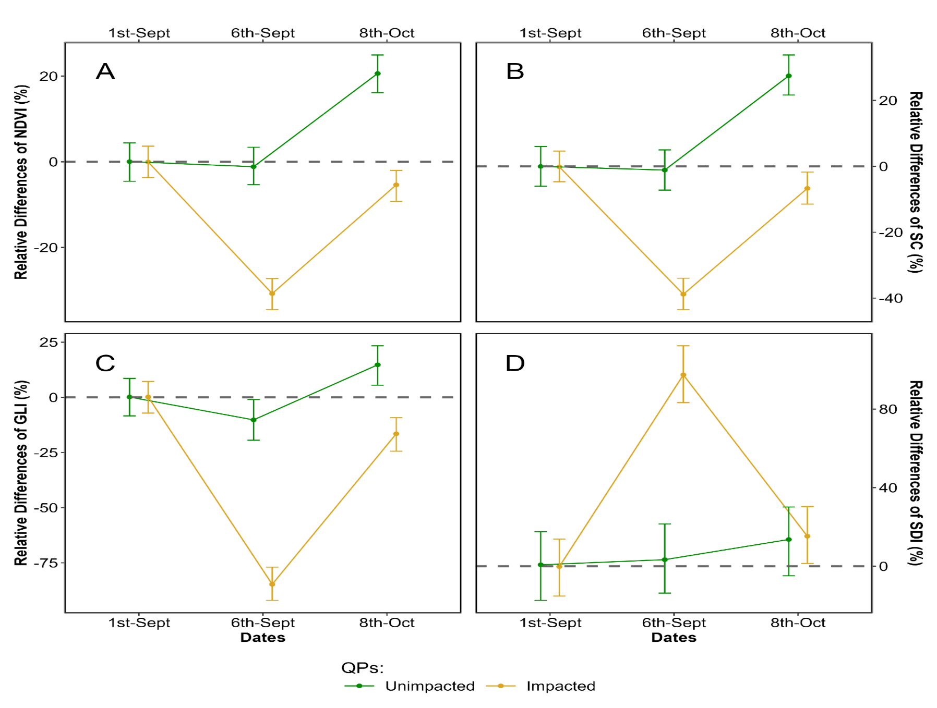
Figure 8: Changes in the relative Seagrass Darkening Index (SDI) estimated from Sentinel-2, before (1st of September 2021), during (6th of September 2021) and after (8th of October 2021) a heatwave in the seagrass meadow of Quiberon (South Brittany, France. The relative SDI difference was calculated using the 1st of September as a reference. SDI was calculated for two categories of quadrat points (Figure 7): unimpacted seagrass (green) and impacted seagrass (orange). Points represent the predicted value of the metric using a Generalized Linear Model (GLM), while the error bar represents the 89% confidence interval.

Using the SDI (Equation 3), we detected large, darkened seagrass patches in the meadow after the heatwave (Figure 9). A total of 26.9 hectares of seagrass turned brown between the 1st and the 6th of September, according to the available Sentinel-2 images. The largest brown patch covered nearly 8 hectares. Overall, 24 % of the total seagrass meadow area showed signs of darkening between the 1st and 6th of September 2021. Comparing the spatial distribution of darkened patches with the site’s topography revealed that 94.6 % of darkened areas were located above a bathymetric level of 3.9 meters (Figure 9, A and B). One month later, on October 8th, previously darkened areas regained their green colour (Figure 9, C).
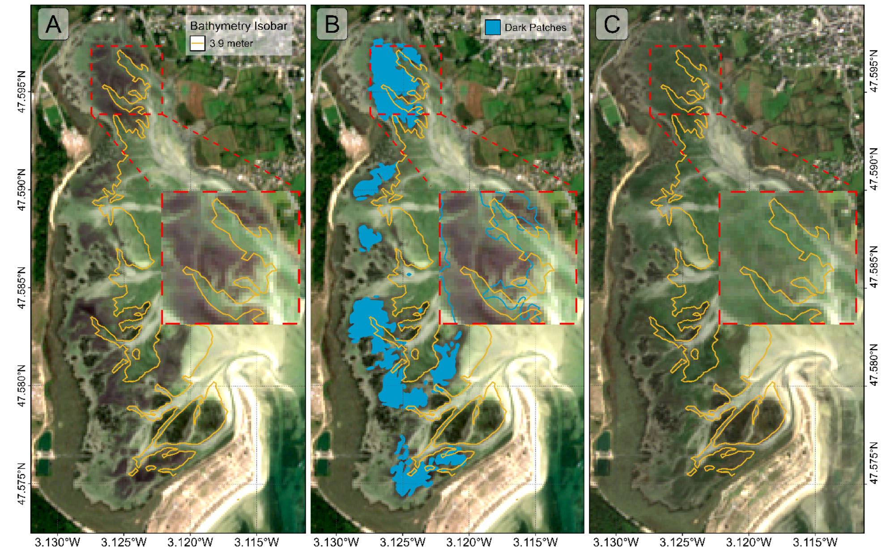
Figure 9: Map of the Darkening of seagrasses during the heatwave events in September 2021 in Quiberon (South Brittany, France). A) RGB color composition of the Sentinel-2 image on the 6th of September 2021 on the second day of a strong AHW. The orange line shows the 3.9 m bathymetric level. B) Result of the detection of darkened seagrass patches (Blue polygons); C) Sentinel-2 image one month after the end of the heatwaves (2021-10-08).
Additionally, seagrass emersion time revealed a clear relationship between the duration of air exposure and seagrass darkening (Figure 10). During the heatwave, no significant darkening occurred with less than 13 hours of daily exposure. However, above 13 hours, seagrasses began to darken, reaching peak darkening at around 14.5 hours of daily exposure.
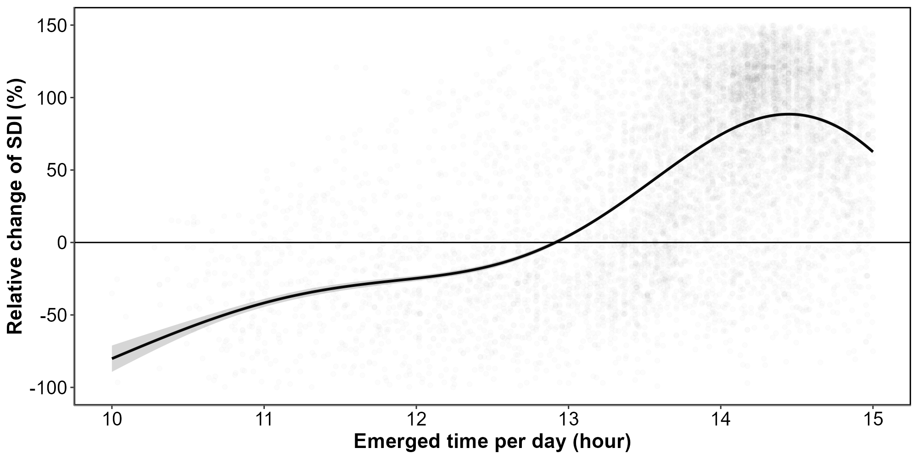
Figure 10: Relative change of the Seagrass Darkening Index (SDI) before and during the heatwave events as a function of the daily emersion time of seagrass. The line represents a Generalized Additive Model (GAM) prediction, and the shaded area indicates the standard error. Shaded points represent raw data, each corresponding to a single pixel of the meadow.

4. Discussion

4.1 Physiological impacts of heatwaves on seagrasses
Although extensive research exists on marine heatwaves’ effects on subtidal seagrasses, little attention has been given to intertidal habitats and even less to the interaction between atmospherical extreme event and intertidal meadows. This study initiates an exploration of how intertidal seagrasses respond to the dual influence of marine and atmospheric heatwaves, underscoring the need for further investigation in this underexplored area.
In the present study, significant changes in the reflectance of seagrasses exposed to heatwaves were observed experimentally. These changes mainly include a drop in reflectance around 560 nm and another drop around 740 nm in the near-infrared part of the spectrum (Figure 5). The second derivative at 665 nm (R’’665), NDVI, and GLI (Figure 5 B, C, and D) all demonstrated a clear decline over the experimental period (days 1-3), suggesting a progressive reduction in photosynthetic activity or pigment levels in the treatment group relative to the control. In contrast, SDI shows a marked increase, reaching up to 600% for some samples by day 3 (Figure 5 E). This positive trend in SDI aligns with its design as an index to indicate darkening of seagrass, likely resulting from structural or physiological changes, such as degraded pigmentation or altered light absorption. While the general trends are consistent across experimental runs, there is some variability, particularly evident in the confidence intervals, which are wider for SDI than for the other indices. This suggests that while darkening is a consistent response, it may vary in intensity between individual samples or experimental runs. Furthermore, the contrasting magnitudes of change—especially the pronounced increases in SDI versus the declines in other indices—highlight the sensitivity of SDI to changes associated with seagrass darkening, which could be indicative of stress or adaptation responses specific to the treatment conditions.
The change in color can be multifactorial and has been documented in plants under various stress conditions, including thermal stress (Dascaliuc et al., 2007; Jones and Clayton-Greene, 1992). Leaf blackening in angiosperms, as observed in Protea neriifolia, is primarily driven by oxidative processes involving the enzyme polyphenol oxidase (PPO) and the oxidation of phenolic compounds. When photosynthesis is inhibited by factors such as low light, chemical interference, or thermal stress, the plant’s production of essential carbohydrates and antioxidants diminishes, increasing oxidative stress and leading to darkening. Experimental essays have proved that low-oxygen environments and the addition of antioxydants like diphenylamine (DPA), have been effective in reducing these oxidative reactions. In the absence of photosynthesis, membrane integrity is also compromised, allowing PPO to interact with phenolic compounds, thereby accelerating darkening. Furthermore, high temperatures can destabilize membranes, especially in chloroplasts, disrupting photosystem II and impairing recovery of photosynthetic function. As chlorophyll-a degrades, the ratio of pigments shift; with pigments like carotenoids becoming more prominent, leading to a darkening of the leaves.
Zostera noltei, as a species inhabiting the intertidal zone and regularly exposed to air, has developed adaptations to minimize water stress. For example, it exhibits smaller, narrower leaves compared to species residing lower in the intertidal zone, such as Zostera marina, which helps reduce water loss during air exposure periods (Cabaço et al., 2009). However, during intense warming events and under high light conditions, desiccation can occur in certain parts of the meadow, particularly where seagrass leaves are exposed for prolonged periods (Figure 10). Under such water stress, cellular turgor pressure decreases (the internal cell water pressure that maintains cell shape), and concentrations of ions like Na+ and Cl– can reach toxic levels. These effects can impair cellular functions, enzymatic activity, and membrane stability.
High infrared reflectance in plant leaves is primarly due to the internal cellular structure that scatters light. Once sunlight enters the leaf, it is diffused through carious layers, particularly the spongy mesophyll, which contains air spaces and cell walls with different refractive indices. this scattering effect is intensified because there is minimal absorption in the near-infrared range (700 - 1300 nm), allowing light to reflect back through the leaf surface. Once the membranes (chloroplasts, thylakoids, cell walls) are destroyed due to oxidative stress, the reflectance in the Red Edge and the near-infrared regions of the spectrum (> 700 nm) decreases significantly (Knipling, 1970).
These unique reflectance properties of seagrasses under heat stress enable the detection of this darkening through remote sensing techniques. The SDI (Equation 3) index developed in this study leverages key reflectance bands (560, 740 and 840 nm) to detect reductions in the green and the Red-Edge regions. SDI can be used to assess the extent and severity of darkening events across intertidal seagrass meadows from space. Current satellite missions, including Sentinel-2, Pleiades-Neo, WorldView-3, SkySat, and GeoSat-2 along with upcoming missions (Sentinel-2 Next Generation and Landsat Next), capture reflectance in the three wavelengths used as input for SDI. As climate change advances, remote sensing becomes a crucial tool for monitoring cumulative ecological impacts on seagrass meadows due to heatwaves. Although these physiological and structural changes occur at the cellular level over short temporal scales, they manifest synchronously across the entire meadow. Remote sensing, with its synoptic views and real-time acquisition capabilities, enables the monitoring of these rapid biological responses to natural stressors. However, cloud coverage can limit continuous observations, necessitating the integration of alternative tools, such as multi-spectral drone platforms. Combined approaches allow for precise, localized monitoring of damaged seagrass meadows immediately after extreme events, which is critical for the early detection of ecosystem degradation, quick actions for habitat conservation and targeted management strategies. Moreover, uninterrupted, multi-year data acquisition would strengthen predictive ecological models for future heatwave impacts, enhancing the capacity for adaptive management and supporting long-term resilience planning for seagrass ecosystems.

4.2 Climate change and heatwaves
The rapid global escalation of heatwave frequency, intensity and duration is a defining characteristic of the current climate crisis, heavily influenced by anthropogenic activities and greenhouse gas emissions (Devi et al., 2024; Russo and Domeisen, 2023). Recent research suggests that the magnitude of these events has surged in the recent decades, with climate projections predicting a continuation of this trend. For example, heatwaves that were once considered rare are now up to ten times more likely to occur, with some regions experiencing events three times as intense as those in the early 20th century. Cumulative indices that quantify heatwave intensity are based on total temperature exceedances and offer a more comprehensive understanding of event severity than average temperature alone. This is because the cumulative impact of prolonged high temperatures imposes more extensive stress on ecosystems than isolated peak temperatures (Russo and Domeisen, 2023).
From a hazard analysis perspective, the concurrent evaluation of intensity, frequency, and duration of atmospheric heatwaves allows for a partial understanding of their likely impacts. Models like the Heatwave Intensity Duration Frequency (HIDF) provide insights into various heatwave scenarios, indicating that both short intense and prolonged moderate events present unique risks depending on the region. For instance, in the Mediterranean, the frequency of high-intensity heatwaves has dramatically increased, leading to severe impacts on urban infrastructure, public health, energy consumption but also to terrestrial and intertidal ecosystems, such as seagrass meadows (Mazdiyasni et al., 2019; Smale et al., 2019). Sharper increase in extreme heat events are expected in regions experiencing large daily thermic amplitude, which underscores the role of atmospheric variability in local heatwave dynamics. In mid-latitudes, where daily variability is expected to decrease, heat extremes may stabilize at elevated levels, reducing cold extremes while allowing for increasingly frequent hot day (Simolo and Corti, 2022).
In the ocean, similar trends are observed with marine heatwaves (MHWs). MHWs have increased by over 50% in annual days since the early 20th century, and projections suggest that a near-permanent state of marine heatwaves, based on nowadays baselines, could develop by the end of the century if greenhouse gas emissions remain high (Oliver et al., 2019). Events like the “Blob” in the northeast Pacific (2013–2016) have underscored the ecological ramifications of such heat anomalies, including shifts in species distributions, mass mortalities, and habitat degradation across vast oceanic regions. The physical mechanisms driving MHWs, such as altered ocean circulation and air-sea heat flux, further illustrate the interconnectedness of atmospheric and marine systems in the context of climate-driven thermal extremes (Smale et al., 2019).
The escalating frequency and intensity of heatwaves represent not only an atmospheric anomaly but a profound disruption to ecological stability across diverse ecosystems (Devi et al., 2024; Stillman, 2019). The sustained high temperatures associated with both atmospheric and marine heatwaves lead to physiological stress, habitat degradation, and increased mortality in many species, particularly those with limited thermal tolerance (Oliver et al., 2019; Simolo and Corti, 2022). Terrestrial and marine ecosystems experience shifts in species distributions, altered community dynamics, and reduced biodiversity as species are either forced to migrate or face local extinction under increasingly inhospitable conditions (Pansch et al., 2018). Similarly, in marine environments, prolonged heat stress from marine heatwaves has cascading effects on foundational species, including corals, kelps, and seagrasses, all of which are crucial for providing habitat, food, and shelter to diverse marine life (Oliver et al., 2019; Smale et al., 2019). Seagrasses, in particular, play a vital role in carbon sequestration and coastal protection but are especially vulnerable to extreme heat events. Elevated temperatures can disrupt seagrass photosynthesis and metabolic processes, leading to reduced growth and heightened susceptibility to disease (Deguette et al., 2022; Guerrero-Meseguer et al., 2020; Sawall et al., 2021; Winters et al., 2011). With repeated heatwave exposure and limited recovery periods, seagrass meadows may suffer severe declines, threatening their ability to deliver key ecosystem services such as carbon storage, sediment stabilization, and habitat provision (Mazdiyasni et al., 2019). The compounded impacts of atmospheric and marine heatwaves thus pose an existential threat to intertidal seagrass ecosystems, highlighting the urgent need for targeted climate adaptation measures to mitigate these escalating thermal stresses and preserve the resilience of these essential marine habitats (Russo and Domeisen, 2023; Stillman, 2019).

4.3 Seagrass resilience to heatwaves
Seagrass resilience to heatwaves is a complex and multifaceted issue shaped by species-specific traits, geographical location, and concurrent environmental stressors (Berger et al., 2024; Canadell and Jackson, 2021; Hatum et al., 2024). As climate change drives the frequency and intensity of marine heatwaves, understanding these dynamics becomes crucial, especially for temperate seagrass meadows composed of slow-growing, long-lived species like Posidonia, Amphibolis, and Zostera. These species, unlike their tropical counterparts, tend to be highly vulnerable to abrupt environmental changes, struggling to recover from disturbances due to their slower growth and longer lifespan. In contrast, colonizing species typical of tropical regions, such as Halodule, Halophila, and Syringodium, demonstrate greater resilience to warming events and marine heatwaves due to their rapid growth and more flexible life strategies (O’Brien et al., 2018).
The impact of heatwaves on seagrass ecosystems is further intensified by tidal variations, especially in temperate regions with tidal ranges that can exceed 10 meters, such as Mont Saint Michel Bay in France. This pronounced tidal amplitude affects intertidal seagrasses like Zostera noltei, which experience varying durations of air exposure based on their position within the intertidal zone. During neap tides, seagrasses situated higher in the intertidal zone may remain exposed for extended periods, heightening their vulnerability to atmospheric heatwaves. Conversely, seagrasses in the lower intertidal zone experience prolonged immersion throughout the tidal cycle, making them susceptible to extreme marine heat events. As a result, both marine and atmospheric heatwaves can increase stress on seagrass meadows, with effects that may be intensified by tidal timing and amplitude. In our study, we observed a darkening effect in the seagrasses, despite our experimental setup simulating tides with consistent 6-hour exposure periods. In natural settings, however, bathymetry plays a significant role, and depending on depth variations, seagrasses may be exposed for even longer durations during low tides. This suggests that in situ exposure times could exacerbate the stress effects observed, as seagrasses may endure prolonged air exposure beyond what our controlled conditions have replicated.
Species like Zostera noltei display distinct seasonal patterns that become increasingly pronounced at higher latitudes (Davies et al., 2024a, 2024b). These patterns reflect the species’ adaptation to seasonal variations in temperature and light, but they also make Z. noltei particularly sensitive to extreme events depending on their timing. For instance, if a heatwave coincides with early developmental stages or occurs after the biomass peak when leaf senescence has begun, the impact on meadow resilience can be severe.
Environmental conditions can moderate seagrass resilience to thermal stress. Seagrass meadows located in areas benefiting from tidal cooling or positioned further from the warmer edges of their geographical ranges often experience reduced heat stress, resulting in higher shoot densities and enhanced resilience (Berger et al., 2024; Canadell and Jackson, 2021). In these cooler areas, Zostera noltei exhibits high survival and photosynthetic performance up to 37°C, though temperatures above 39°C lead to near-total mortality within days, underscoring the species’ sensitivity to temperature thresholds that may become increasingly common under climate change scenarios (Franssen et al., 2014). Moreover, the frequency, duration, and intervals between heatwaves significantly affect seagrass biomass and recovery; prolonged and frequent heatwaves reduce resilience and complicate recovery processes (Hatum et al., 2024).
The influence of other stressors, such as eutrophication and sulfide accumulation, complicates this resilience. Increased sediment sulfide levels, which often accompany nutrient enrichment, can be toxic to seagrasses, particularly under elevated temperatures that amplify sulfide toxicity. Zostera noltei, for example, has a mutualistic relationship with lucinid clams that helps detoxify sulfides. However, this interaction is compromised at high temperatures, reducing the efficacy of sulfide removal and further inhibiting nutrient uptake, growth, and overall resilience (De Fouw et al., 2022).
In a simulated heatwave experiment on Zostera noltei, resilience was evident under short-term moderate stress, with no significant changes in photosynthetic performance or survival (Franssen et al., 2014; Massa et al., 2009). However, prolonged or more intense heat events posed a greater challenge, highlighting the species’ limited capacity to withstand chronic thermal stress. The long-term impact of heatwaves is especially evident in changes to seagrass cover (SC). Before the heatwave event on 1st September 2021, impacted seagrass patches exhibited higher SC than non-impacted areas. However, during the event on 6th September, SC in the impacted patch experienced a sharp decline. By 8th October, one month post-event, the SC of impacted seagrasses, initially higher, had fallen below that of non-impacted seagrasses (Figure 8). The observed decrease in seagrass cover on 6th September was primarily due to leaf darkening, which influenced the NDVI measurements used to estimate SC. This darkening effect reduced the NDVI values, creating an apparent decrease in SC in the impacted patch when, in reality, the density of seagrass remained stable (Figure 3). The bias introduced by remote sensing in this instance reflects a limitation in accurately capturing true seagrass cover during stress events. It was only after the heatwave that leaves began to detach, leading to an actual decline in seagrass density. This delayed physical response underscores how extreme events can compromise seagrass resilience, leaving previously robust patches in a weakened state compared to less disturbed areas (Figure 8).
On a physiological level, seagrasses possess coping mechanisms such as photoprotective responses and heat-responsive gene expression, including the activation of heat-shock proteins (HSPs) and other stress-related genes (Hughes and Stachowicz, 2004; Reusch et al., 2005). Zostera noltei, in particular, has shown differential gene expression responses to heat stress, with a variety of genes involved in protein folding, membrane stability, and reactive oxygen species scavenging playing critical roles. However, the rapid pace of climate change raises concerns about whether these adaptations can keep up with the increasing frequency and severity of thermal events (Franssen et al., 2014).

4.4 Big picture
Given the combined pressures of temperature extremes, eutrophication, and other anthropogenic impacts, targeted management strategies are essential for enhancing seagrass resilience (Loarie et al., 2009). Approaches such as reducing local stressors, cultivating heat-tolerant genotypes, and investing in restoration initiatives are vital to supporting these ecosystems in a warming climate. Although challenges remain, the adaptability and potential resilience of certain seagrass species offer hope for their persistence amid accelerating ecological shifts. In particular, regions that can buffer seagrasses from extreme stressors or provide cooler refuges may play a critical role in maintaining these valuable ecosystems in the face of global climate change (Canadell and Jackson, 2021; De Fouw et al., 2022).
Seagrass meadows function as foundational components of coastal ecosystems, sustaining diverse marine communities by providing essential habitats, nursery grounds, and trophic resources for fish, invertebrates, and migratory birds (Zoffoli et al., 2023). Their dense canopies stabilize sediment and protect shorelines from erosion, an increasingly crucial role as sea levels rise due to climate change (Folmer et al., 2012; Gacia et al., 1999). Recurrent heatwave events, which induce physiological stress like leaf darkening, can severely diminish seagrass density, thereby reducing their effectiveness in sediment stabilization and wave attenuation, ultimately increasing the risk of coastal erosion (Calleja et al., 2007). From a biodiversity perspective, degradation of these meadows disrupts intricate food webs, impacting commercially significant fish and shellfish populations that rely on seagrass for sustenance and refuge. This loss can reduce local fisheries’ productivity and threaten the livelihoods of coastal communities (Unsworth and Cullen-Unsworth, 2014). Furthermore, as seagrasses decline, their capacity to act as a blue carbon sink—critical for climate mitigation—also diminishes, inadvertently contributing to increased atmospheric carbon levels (Armitage and Fourqurean, 2016; Samper-Villarreal et al., 2020)

5. Conclusion
This research has investigated the effects of both marine and atmospheric heatwaves on the intertidal seagrass Zostera noltei, a critical component of coastal ecosystems facing increased thermal stress due to climate change. By examining reflectance and pigment composition under controlled experimental conditions and validating these findings with satellite data, we aimed to understand how extreme heat events impact seagrass health and assess the potential of remote sensing to monitor these effects effectively. Our findings reveal that heatwaves lead to substantial declines in seagrass reflectance, particularly in the green and near-infrared regions, likely driven by pigment degradation and structural damage. This change is reflected in significant reductions in key vegetation indices such as NDVI and GLI. The Seagrass Darkening Index (SDI), developed in this study, successfully detected seagrass darkening, a visible symptom of heatwave stress, demonstrating the viability of spectral monitoring to capture early-stage impacts of heat events on intertidal ecosystems. By connecting our findings with satellite data, we have also confirmed the broader spatial impact of heatwaves on seagrass meadows in Quiberon, France. The correlation between heatwave exposure and darkening of seagrass suggests that remote sensing, combined with targeted field observations, can enhance our understanding of ecosystem responses to climate-driven thermal events. These results advocate for integrating continuous spectral monitoring into conservation strategies, as it can help predict the resilience of these ecosystems and guide adaptive management practices. As climate change accelerates, with an anticipated increase in the frequency and intensity of heatwaves, the vulnerability of intertidal zones to such events will likely intensify. This study not only underscores the importance of seagrass meadows in coastal ecosystems but also highlights the urgency of protecting these critical habitats. Future work should focus on refining remote sensing tools and examining the cumulative effects of repeated heatwave events to support the resilience and conservation of intertidal seagrass meadows in a warming world.

6. Annexes

6.1 Annexes A - Temperatures of the experiment
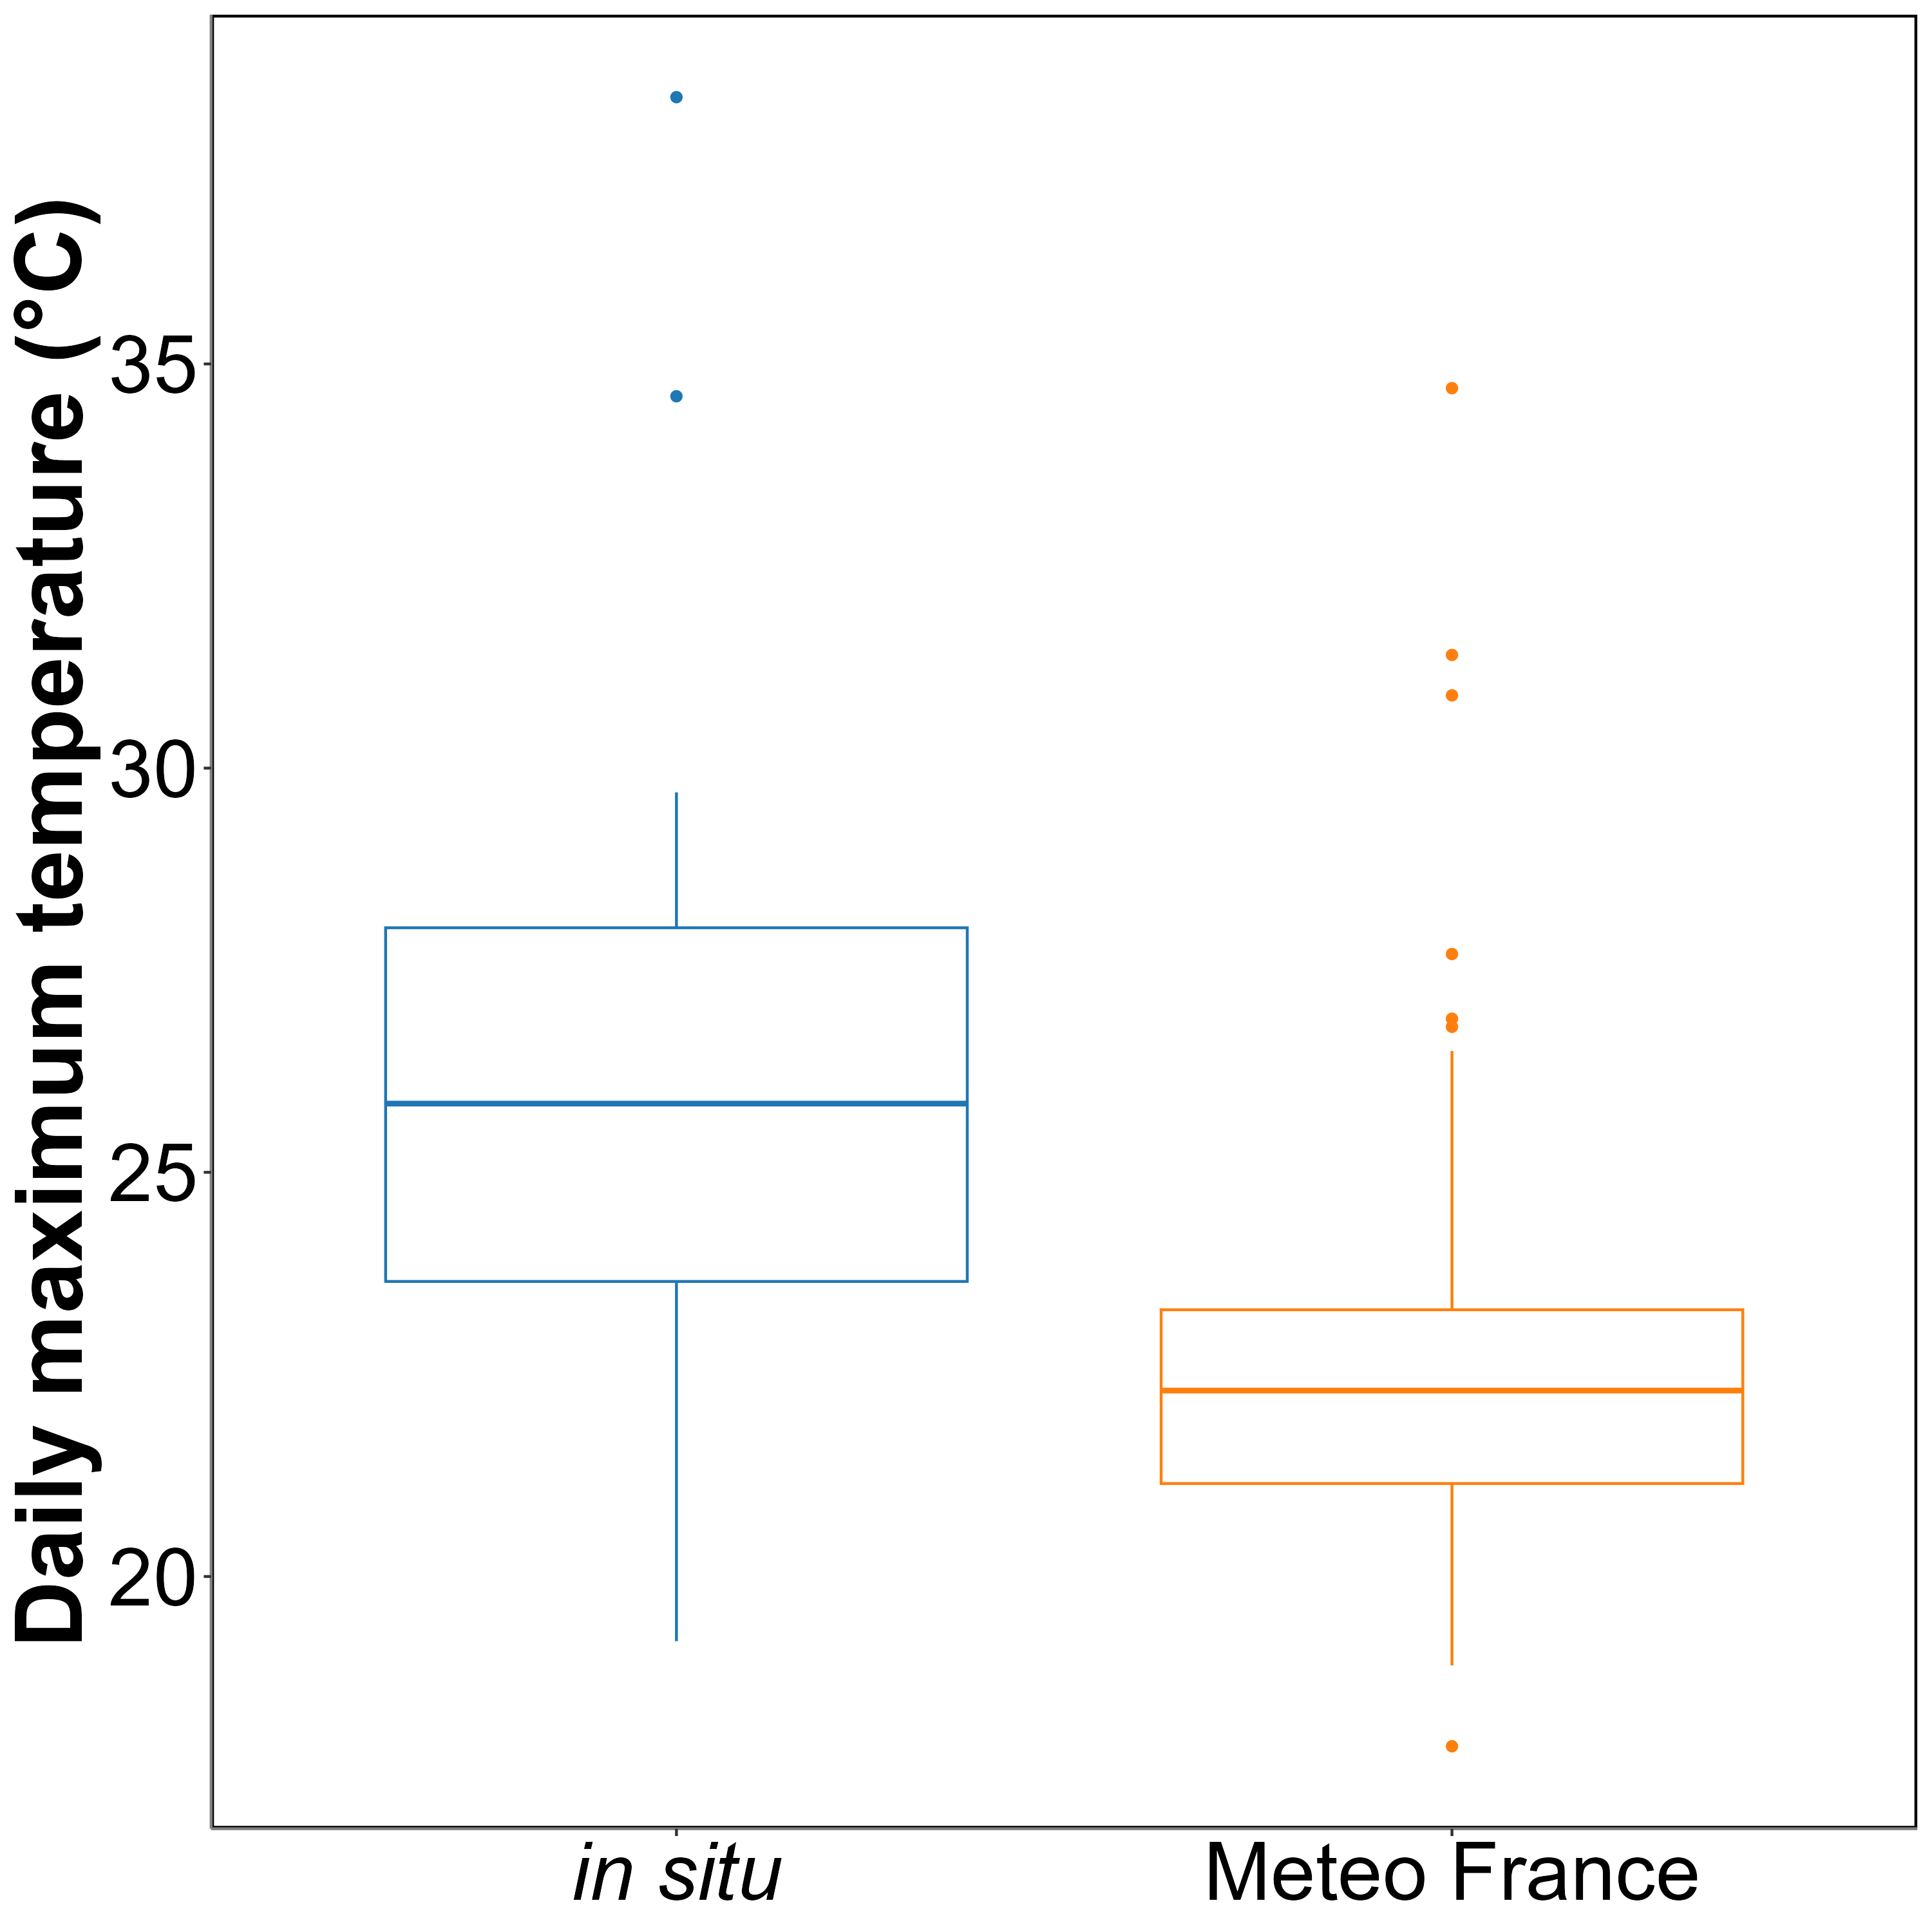
Annexe A1: Comparison of daily maximum temperatures in August measured using an in-situ sensor (blue) and retrieved from Meteo France (orange). The solid line in the middle of the boxplot represents the median, the two ends of the box represent the 25th and 75th percentiles, and the whiskers represent values that are no more than 1.5 times the interquartile range.
On average, in situ temperatures were 3 ± 3.2°C higher than those recorded by Meteo France. Additionally, temperatures recorded by Meteo France were more stable than those from the in situ sensors, likely due to the sheltered and shaded location of the Meteo France equipment. This difference was used to adjust heatwave temperatures measured by Meteo France to better reflect the conditions experienced by the seagrasses.
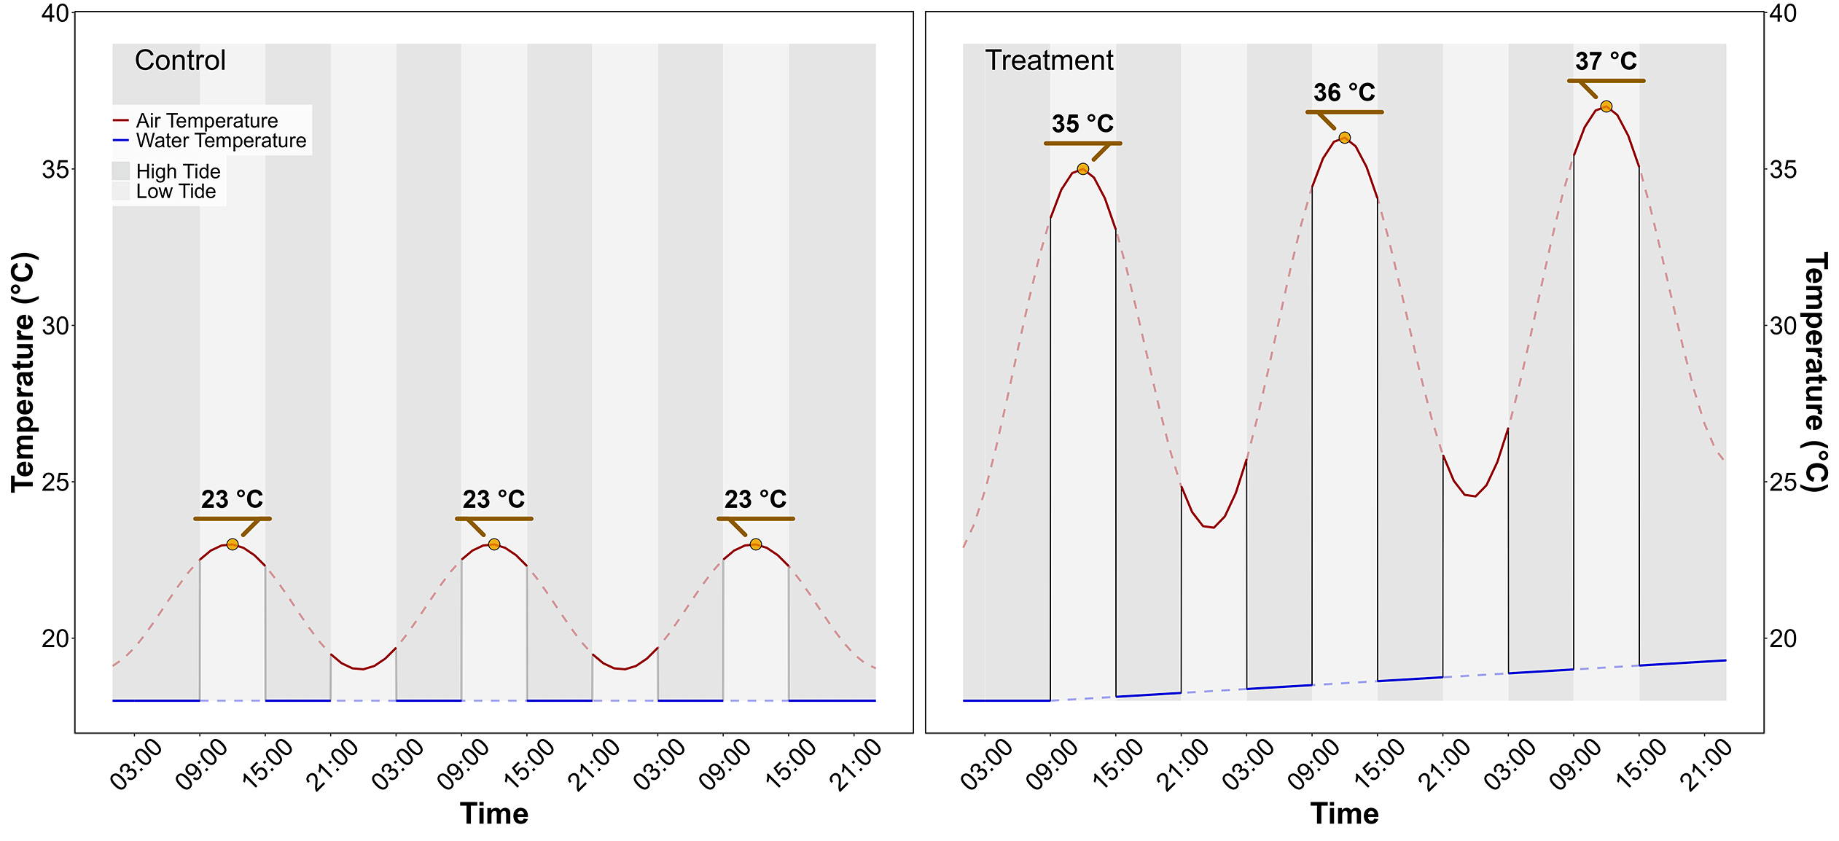
Annexe A2: Temperature profiles of both the control (left) and the treatment (right) followed during the heatwave experiment. The red line indicates air temperature, whereas the blue line indicates water temperature. With the tidal cycle simulated in the experimental chambers, the seagrasses only experienced temperatures represented by solid lines.

7. References
Akbar, M., Arisanto, P., Sukirno, B., Merdeka, P., Priadhi, M., Zallesa, S., 2020. Mangrove vegetation health index analysis by implementing NDVI (normalized difference vegetation index) classification method on sentinel-2 image data case study: Segara anakan, kabupaten cilacap, in: IOP Conference Series: Earth and Environmental Science. IOP Publishing, p. 012069.
Armitage, A., Fourqurean, J.W., 2016. Carbon storage in seagrass soils: Long-term nutrient history exceeds the effects of near-term nutrient enrichment. Biogeosciences 13, 313–321.
Bastos, M., Roebeling, P., Alves, F.L., Villasante, S., Magalhães Filho, L., 2023. High risk water pollution hazards affecting aveiro coastal lagoon (portugal)–a habitat risk assessment using InVEST. Ecological Informatics 76, 102144.
Berger, A.C., Berg, P., McGlathery, K.J., Aoki, L.R., Kerns, K., 2024. Eelgrass meadow response to heat stress. II. Impacts of ocean warming and marine heatwaves measured by novel metrics. Marine Ecology Progress Series 736, 47–62. https://doi.org/10.3354/meps14588
Bürkner, P.-C., 2021. Bayesian item response modeling in r with brms and stan. Journal of Statistical Software 100, 1–54. https://doi.org/10.18637/jss.v100.i05
Cabaço, S., Machás, R., Santos, R., 2009. Individual and population plasticity of the seagrass zostera noltii along a vertical intertidal gradient. Estuarine, Coastal and Shelf Science 82, 301–308.
Calleja, M.L., Marbà, N., Duarte, C.M., 2007. The relationship between seagrass (posidonia oceanica) decline and sulfide porewater concentration in carbonate sediments. Estuarine, Coastal and Shelf Science 73, 583–588.
Canadell, J.G., Jackson, R.B., 2021. Ecosystem collapse and climate change. Springer.
Cârlan, I., Mihai, B.-A., Nistor, C., Große-Stoltenberg, A., 2020. Identifying urban vegetation stress factors based on open access remote sensing imagery and field observations. Ecological Informatics 55, 101032.
Carpenter, B., Gelman, A., Hoffman, M.D., Lee, D., Goodrich, B., Betancourt, M., Brubaker, M., Guo, J., Li, P., Riddell, A., 2017. Stan: A probabilistic programming language. Journal of Statistical Software 76, 1–32. https://doi.org/10.18637/jss.v076.i01
CMEMS, 2024. European north west shelf/iberia biscay irish seas – high resolution ODYSSEA sea surface temperature multi-sensor L3 observations reprocessed, e.u. Copernicus marine service information (CMEMS). Marine data store (MDS). (Accessed on 17-10-2024). https://doi.org/10.48670/moi-00311
Dascaliuc, A., Ralea, T., Cuza, P., 2007. Influence of heat shock on chlorophyll fluorescence of white oak (quercus pubescens willd.) leaves. Photosynthetica 45, 469–471. https://doi.org/10.1007/s11099-007-0084-3
Davies, B.F.R., Oiry, S., Rosa, P., Zoffoli, M.L., Sousa, A.I., Thomas, O.R., Smale, D.A., Austen, M.C., Biermann, L., Attrill, M.J., others, 2024a. A sentinel watching over inter-tidal seagrass phenology across western europe and north africa. Communications Earth & Environment 5, 382. https://doi.org/10.1038/s43247-024-01543-z
Davies, B.F.R., Oiry, S., Rosa, P., Zoffoli, M.L., Sousa, A.I., Thomas, O.R., Smale, D.A., Austen, M.C., Biermann, L., Attrill, M.J., others, 2024b. Intertidal seagrass extent from sentinel-2 time-series show distinct trajectories in western europe. Remote Sensing of Environment 312, 114340. https://doi.org/10.1016/j.rse.2024.114340
De Fouw, J., Rehlmeyer, K., Geest, M. van der, Smolders, A.J., Van Der Heide, T., 2022. Increased temperature reduces the positive effect of sulfide-detoxification mutualism on zostera noltii nutrient uptake and growth. Marine Ecology Progress Series 692, 43–52.
Deguette, A., Barrote, I., Silva, J., 2022. Physiological and morphological effects of a marine heatwave on the seagrass cymodocea nodosa. Scientific Reports 12, 7950.
Devi, R., Gouda, K., Lenka, S., 2024. Intensity duration and frequency of heat wave in different phases of MJO over india. Atmospheric Research 300, 107250.
European Space Agency, 2024b. Sen2Cor: Sentinel-2 atmospheric correction processor.
European Space Agency, 2024a. Copernicus open access hub.
Folmer, E.O., Geest, M. van der, Jansen, E., Olff, H., Michael Anderson, T., Piersma, T., Gils, J.A. van, 2012. Seagrass–sediment feedback: An exploration using a non-recursive structural equation model. Ecosystems 15, 1380–1393.
Franssen, S.U., Gu, J., Winters, G., Huylmans, A.-K., Wienpahl, I., Sparwel, M., Coyer, J.A., Olsen, J.L., Reusch, T.B., Bornberg-Bauer, E., 2014. Genome-wide transcriptomic responses of the seagrasses zostera marina and nanozostera noltii under a simulated heatwave confirm functional types. Marine Genomics 15, 65–73.
Gacia, E., Granata, T., Duarte, C., 1999. An approach to measurement of particle flux and sediment retention within seagrass (posidonia oceanica) meadows. Aquatic Botany 65, 255–268.
Gardner, R.C., Finlayson, C., 2018. Global wetland outlook: State of the world’s wetlands and their services to people, in: Ramsar Convention Secretariat. pp. 2020–5.
Guerrero-Meseguer, L., Marı́n, A., Sanz-Lázaro, C., 2020. Heat wave intensity can vary the cumulative effects of multiple environmental stressors on posidonia oceanica seedlings. Marine Environmental Research 159, 105001.
Hatum, P.S., McMahon, K., Mengersen, K., Kilminster, K., Wu, P.P.-Y., 2024. Predicting seagrass ecosystem resilience to marine heatwave events of variable duration, frequency and re-occurrence patterns with gaps. Aquatic Conservation: Marine and Freshwater Ecosystems 34, e4210. https://doi.org/10.1002/aqc.4210
Hobday, A.J., Alexander, L.V., Perkins, S.E., Smale, D.A., Straub, S.C., Oliver, E.C., Benthuysen, J.A., Burrows, M.T., Donat, M.G., Feng, M., others, 2016. A hierarchical approach to defining marine heatwaves. Progress in oceanography 141, 227–238.
Hobday, A.J., Oliver, E.C., Gupta, A.S., Benthuysen, J.A., Burrows, M.T., Donat, M.G., Holbrook, N.J., Moore, P.J., Thomsen, M.S., Wernberg, T., others, 2018. Categorizing and naming marine heatwaves. Oceanography 31, 162–173.
Huete, A.R., 2012. Vegetation indices, remote sensing and forest monitoring. Geography Compass 6, 513–532.
Hughes, A.R., Stachowicz, J.J., 2004. Genetic diversity enhances the resistance of a seagrass ecosystem to disturbance. Proceedings of the National Academy of Sciences 101, 8998–9002. https://doi.org/10.1073/pnas.0402642101
IOC, 2024. Intergovernmental oceanographic commission ; sea level monitoring station - le conquet, france (LECY).
Jankowska, E., Michel, L.N., Lepoint, G., Włodarska-Kowalczuk, M., 2019. Stabilizing effects of seagrass meadows on coastal water benthic food webs. Journal of Experimental Marine Biology and Ecology 510, 54–63.
Jones, R.B., Clayton-Greene, K.A., 1992. The role of photosynthesis and oxidative reactions in leaf blackening of protea neriifolia r. Br. leaves. Scientia Horticulturae 50, 137–145. https://doi.org/10.1016/S0304-4238(05)80016-0
Kloos, S., Yuan, Y., Castelli, M., Menzel, A., 2021. Agricultural drought detection with MODIS based vegetation health indices in southeast germany. Remote Sensing 13, 3907.
Knipling, E.B., 1970. Physical and physiological basis for the reflectance of visible and near-infrared radiation from vegetation. Remote Sensing of Environment 1, 155–159. https://doi.org/10.1016/S0034-4257(70)80021-9
Lehnert, L.W., Meyer, H., Bendix, J., 2017. Hsdar: Manage, analyse and simulate hyperspectral data in r.
Loarie, S.R., Duffy, P.B., Hamilton, H., Asner, G.P., Field, C.B., Ackerly, D.D., 2009. The velocity of climate change. Nature 462, 1052–1055.
Louhaichi, M., Borman, M.M., Johnson, D.E., 2001. Spatially located platform and aerial photography for documentation of grazing impacts on wheat. Geocarto International 16, 65–70.
Malvern Panalytical, 2023. RS3 software.
Massa, S., Arnaud-Haond, S., Pearson, G., Serrão, E., 2009. Temperature tolerance and survival of intertidal populations of the seagrass zostera noltii (hornemann) in southern europe (ria formosa, portugal). Hydrobiologia 619, 195–201.
Mazdiyasni, O., Sadegh, M., Chiang, F., AghaKouchak, A., 2019. Heat wave intensity duration frequency curve: A multivariate approach for hazard and attribution analysis. Scientific Reports 9, 14117. https://doi.org/10.1038/s41598-019-50643-w
O’Brien, K.R., Waycott, M., Maxwell, P., Kendrick, G.A., Udy, J.W., Ferguson, A.J., Kilminster, K., Scanes, P., McKenzie, L.J., McMahon, K., others, 2018. Seagrass ecosystem trajectory depends on the relative timescales of resistance, recovery and disturbance. Marine Pollution Bulletin 134, 166–176.
Oliver, E.C.J., Burrows, M.T., Donat, M.G., others, 2019. Projected marine heatwaves in the 21st century and the potential for ecological impact. Frontiers in Marine Science 6, 734. https://doi.org/10.3389/fmars.2019.00734
Pansch, C., Scotti, M., Barboza, F.R., others, 2018. Heat waves and their significance for a temperate benthic community: A near-natural experimental approach. Global Change Biology 24, 4357–4367. https://doi.org/10.1111/gcb.14282
Papathanasopoulou, E., Simis, S., Alikas, K., Ansper, A., Anttila, J., Barillé, A., Barillé, L., Brando, V., Bresciani, M., Bučas, M., others, 2019. Satellite-assisted monitoring of water quality to support the implementation of the water framework directive. EOMORES white paper.
Perkins, S.E., Alexander, L.V., 2013. On the measurement of heat waves. Journal of climate 26, 4500–4517.
R Core Team, 2023. R: A language and environment for statistical computing. R Foundation for Statistical Computing, Vienna, Austria.
Ramesh, C., Mohanraju, R., 2020. Seagrass ecosystems of andaman and nicobar islands: Status and future perspective. Environmental & Earth Sciences Research Journal 7.
Reusch, T.B., Ehlers, A., Hämmerli, A., Worm, B., 2005. Ecosystem recovery after climatic extremes enhanced by genotypic diversity. Proceedings of the National Academy of Sciences 102, 2826–2831. https://doi.org/10.1073/pnas.0500008102
Rouse, J.W., Haas, R.H., Schell, J.A., Deering, D.W., others, 1974. Monitoring vegetation systems in the great plains with ERTS. NASA Spec. Publ 351, 309.
Russo, E., Domeisen, D.I.V., 2023. Increasing intensity of extreme heatwaves: The crucial role of metrics. Geophysical Research Letters 50, e2023GL103540. https://doi.org/10.1029/2023GL103540
Samper-Villarreal, J., Bolaños, R.C., Heidemeyer, M., Vargas, M.M., Vargas, R.M., 2020. Characterization of seagrasses at two new locations in the eastern tropical pacific (el jobo and matapalito, costa rica). Aquatic botany 165, 103237.
Sawall, Y., Ito, M., Pansch, C., 2021. Chronically elevated sea surface temperatures revealed high susceptibility of the eelgrass zostera marina to winter and spring warming. Limnology and Oceanography 66, 4112–4124.
Schlegel, R.W., Smit, A.J., 2018. heatwaveR: A central algorithm for the detection of heatwaves and cold-spells. Journal of Open Source Software 3, 821. https://doi.org/10.21105/joss.00821
Scott, A.L., York, P.H., Duncan, C., Macreadie, P.I., Connolly, R.M., Ellis, M.T., Jarvis, J.C., Jinks, K.I., Marsh, H., Rasheed, M.A., 2018. The role of herbivory in structuring tropical seagrass ecosystem service delivery. Frontiers in Plant Science 9, 127.
Sevgi, K., Leblebici, S., 2022. Bitkilerde ağır metal stresine verilen fizyolojik ve moleküler yanıtlar. Journal of Anatolian Environmental and Animal Sciences 7, 528–536.
Shom, 2022. Service hydrographique et océanographique de la marine ; références altimétriques maritimes: Ports de france métropolitaine et d’outre-mer, cotes du zéro hydrographique et niveaux caractéristiques de la marée. Shom, Brest, France.
SHOM, 2021. Service hydrographique et océanographique de la marine ; bathymétrie Litto3D® bretagne 2018-2021.
Simolo, C., Corti, S., 2022. Quantifying the role of variability in future intensification of heat extremes. Nature Communications 13. https://doi.org/10.1038/s41467-022-35571-0
Smale, D.A., Wernberg, T., Oliver, E.C.J., others, 2019. Marine heatwaves threaten global biodiversity and the provision of ecosystem services. Nature Climate Change 9, 306–312. https://doi.org/10.1038/s41558-019-0412-1
Sousa, A.I., Silva, J.F. da, Azevedo, A., Lillebø, A.I., 2019. Blue carbon stock in zostera noltei meadows at ria de aveiro coastal lagoon (portugal) over a decade. Scientific reports 9, 14387.
Stan Development Team, C., others, 2020. RStan: The r interface to stan. R package version 2.21. 2.
Stillman, J.H., 2019. Heat waves, the new normal: Summertime temperature extremes will impact animals, ecosystems, and human communities. Physiology 34, 86–100. https://doi.org/10.1152/physiol.00040.2018
Thomsen, E., Herbeck, L.S., Viana, I.G., Jennerjahn, T.C., 2023. Meadow trophic status regulates the nitrogen filter function of tropical seagrasses in seasonally eutrophic coastal waters. Limnology and Oceanography 68, 1906–1919.
Unsworth, R., Cullen-Unsworth, L.C., 2014. Biodiversity, ecosystem services, and the conservation of seagrass meadows. Coast. Conserv 19, 95.
Unsworth, R.K., Cullen-Unsworth, L.C., Jones, B.L., Lilley, R.J., 2022. The planetary role of seagrass conservation. Science 377, 609–613.
Waycott, M., Duarte, C.M., Carruthers, T.J., Orth, R.J., Dennison, W.C., Olyarnik, S., Calladine, A., Fourqurean, J.W., Heck Jr, K.L., Hughes, A.R., others, 2009. Accelerating loss of seagrasses across the globe threatens coastal ecosystems. Proceedings of the national academy of sciences 106, 12377–12381.
Winters, G., Nelle, P., Fricke, B., Rauch, G., Reusch, T.B., 2011. Effects of a simulated heat wave on photophysiology and gene expression of high-and low-latitude populations of zostera marina. Marine Ecology Progress Series 435, 83–95.
Zahoor, I., Mushtaq, A., 2023. Water pollution from agricultural activities: A critical global review. Int. J. Chem. Biochem. Sci 23, 164–176.
Zoffoli, M.L., Gernez, P., Godet, L., Peters, S., Oiry, S., Barillé, L., 2021. Decadal increase in the ecological status of a north-atlantic intertidal seagrass meadow observed with multi-mission satellite time-series. Ecological Indicators 130, 108033.
Zoffoli, M.L., Gernez, P., Oiry, S., Godet, L., Dalloyau, S., Davies, B.F.R., Barillé, L., 2023. Remote sensing in seagrass ecology: Coupled dynamics between migratory herbivorous birds and intertidal meadows observed by satellite during four decades. Remote Sensing in Ecology and Conservation 9, 420–433. https://doi.org/10.1002/rse2.319
Zoffoli, M.L., Gernez, P., Rosa, P., Le Bris, A., Brando, V.E., Barillé, A.-L., Harin, N., Peters, S., Poser, K., Spaias, L., others, 2020. Sentinel-2 remote sensing of zostera noltei-dominated intertidal seagrass meadows. Remote Sensing of Environment 251, 112020.

Institut des Substances et Organismes de la Mer, ISOMer, Nantes Université, UR 2160, F-44000 Nantes, France
Consiglio Nazionale delle Ricerche, Istituto di Scienze Marine (CNR-ISMAR), 00133 Rome, Italy
Bio-littoral, Immeuble Le Nevada, 2 Rue du Château de l’Eraudière, 44300 Nantes, France

